**Sequence Diagram**

Chat Publicly

* Entity classes: Message
* Boundary class: PublicChatInterface
* Controller class: PublicChatController

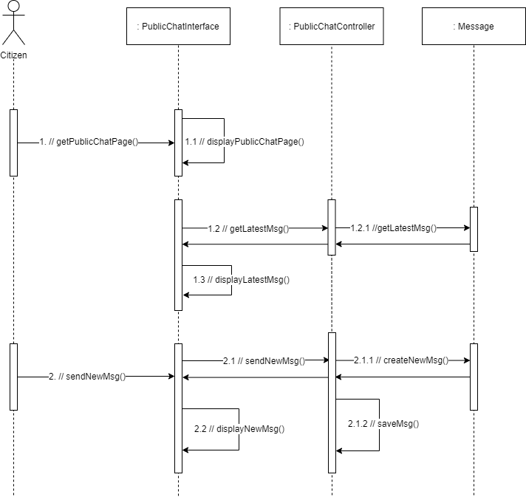

**Class Diagram**

Chat publicly

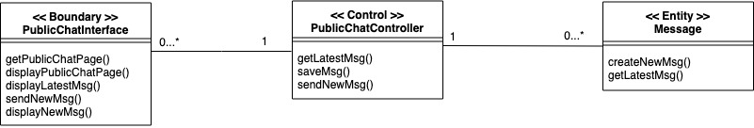

**Mapping between UML Diagram and Code Structure**

|  |  |  |
| --- | --- | --- |
| Analysis Class Type | Analysis Class | Corresponding Code Element |
| Boundary | PublicChatInterface | frontend/page/publicchat.js |
| Control | PublicChatController | backend/controllers/chat.js |
| Entity | Message | backend/models/Messages.ts |